**AIM: Programs based on interfacing LEDs, Servo Motor, Potentiometer with Arduino.**

**THEORY:**

**Servo Motor:**

A Servo Motor is a small device that has an output shaft. This shaft can be positioned to specific angular positions by sending the servo a coded signal. As long as the coded signal exists on the input line, the servo will maintain the angular position of the shaft. If the coded signal changes, the angular position of the shaft changes. In practice, servos are used in radio-controlled airplanes to position control surfaces like the elevators and rudders. They are also used in radio-controlled cars, puppets, and of course, robots.

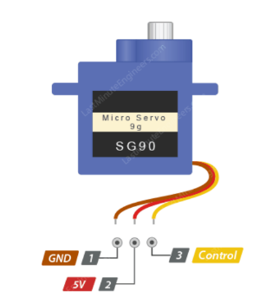

GND is a common ground for both the motor and logic.

5V is a positive voltage that powers the servo.

Control is input for the control system.

**map():** which re-maps a number from one range to another. So, below line changes the reading to represent the angle between 0 and 180 degrees.

**write():** command that tells the servo to update its position to the angle selected by the potentiometer.

**Potentiometer:**

A potentiometer is a manually adjustable variable resistor with 3 terminals.

Two terminals are connected to both ends of a resistive element, and the third terminal connects to a sliding contact, called a wiper, moving over the resistive element. The position of the wiper determines the output voltage of the potentiometer.

The potentiometer essentially functions as a variable voltage divider. The resistive element can be seen as two resistors in series (potentiometer resistance), where the wiper position determines the resistance ratio of the first resistor to the second resistor.

A potentiometer is also commonly known as a potmeter or pot. The most common form of potmeter is the single turn rotary potmeter. This type of pot is often used in audio volume control (logarithmic taper) as well as many other applications. Different materials are used to construct potentiometers, including carbon composition, cermet, wirewound, conductive plastic or metal film.

**CIRCUIT DIAGRAM:**

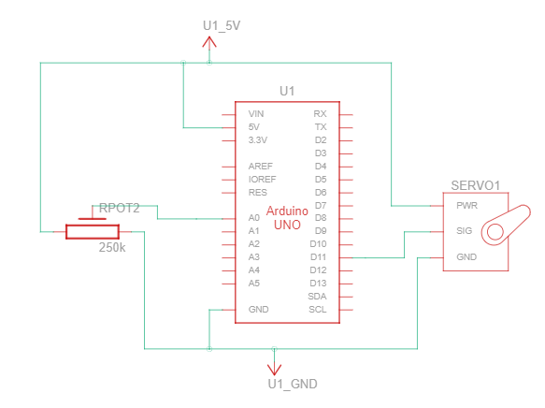

**SOURCE CODE:**

#include<Servo.h>

Servo sm;

const int pot = A0;

void setup()

{

pinMode(pot, INPUT);

sm.attach(11); // ~ PWM Pin

Serial.begin(9600);

}

void loop()

{

int potValue = analogRead(pot);

delay(100);

// map(analog_reading, in_min, in_max, out_min, out_max);

potValue = map(potValue, 0, 1023, 0, 180);

sm.write(potValue);

delay(500);

}

**OUTPUT:**

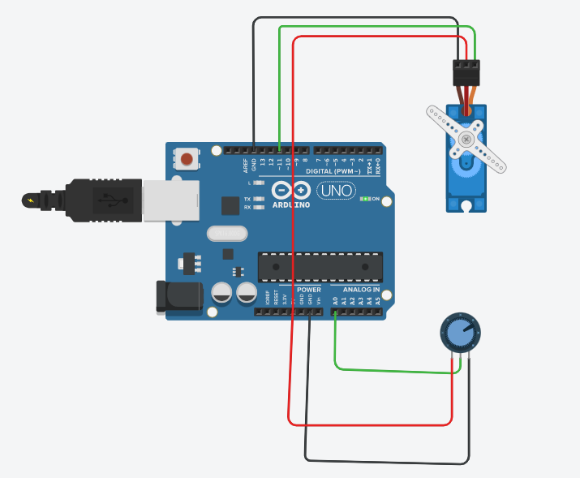

**CONCLUSION:**

From this practical, I have learned and implemented the servo motor in arduino.